# Top 11 Books To Read If You Are Trying To Conceive

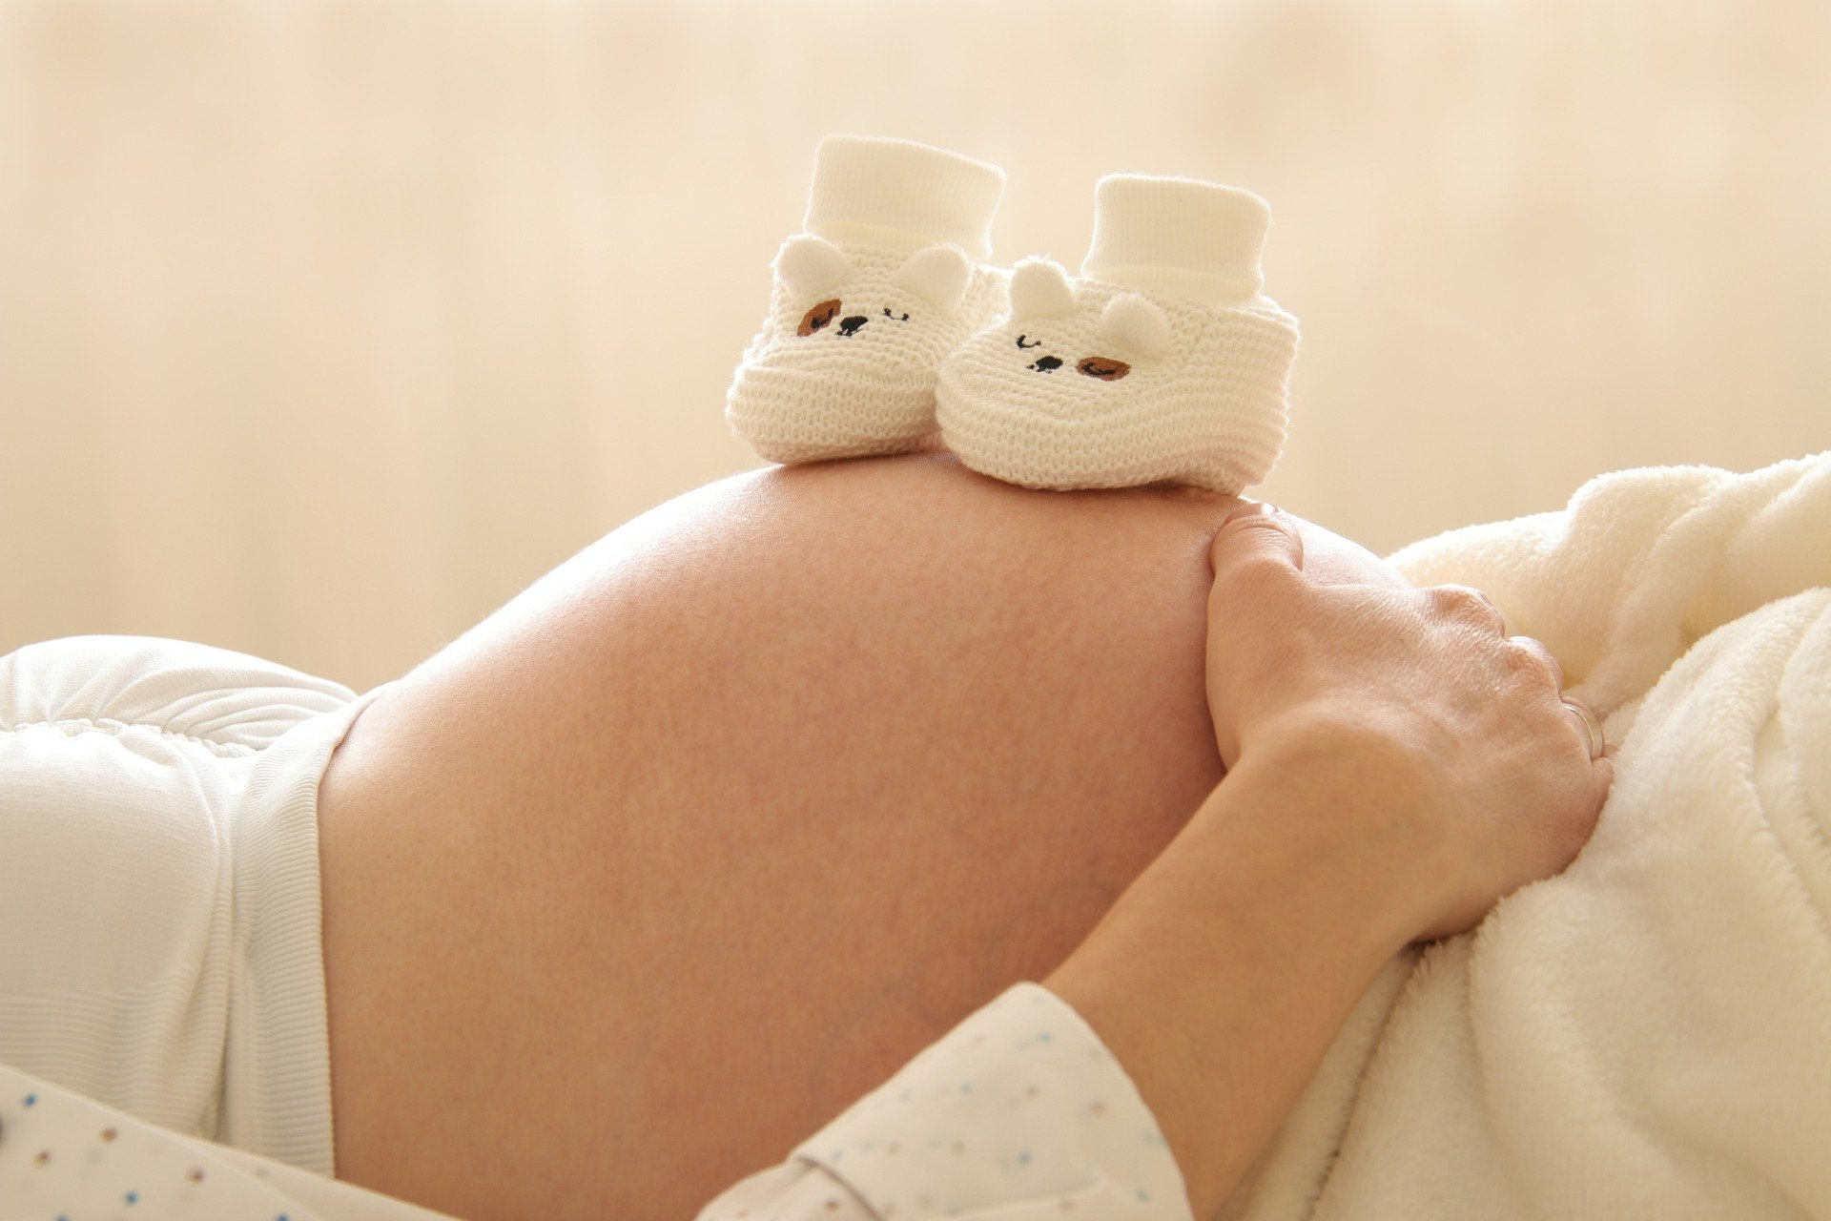

<https://cdn.pixabay.com/photo/2021/04/18/17/03/pregnant-6189040_1280.jpg>

We have collected the 11 books for you to read before you conceive a baby. That is a lovely worthy dream and responsibility at the same time. Gain new knowledge, skills, and way of thinking. Do not forget to keep in touch with a trusted doctor as long as that task requires a complex solution. Thus, start with the 11 books below!

## It Starts With The Egg

The book of Rebecca Fett is the true bestseller of this type of literature. That is reasonable because her volume contains information and results on the latest medical research on fertility, female health, and childbirth. All the represented approaches are based on the ultimate idea that the quality of the egg affects the duration to get pregnancy and the chances to give birth to a healthy child. This suggested program is for three months and includes the range of all required activities and diagnostics. You can follow the tips even if your case is exceptional and challenging. Keep trying and consulting the doctor you trust to make your dream come true!

## What To Expect: Before You’re Expecting

That is a true must-have for a couple that plans to conceive. What tips could it contain? Let's reveal a bit from the list of things to consider. First, prepare your mental condition. Second, qualify your body. That refers to both mother- and farther-to-be. Doctors recommend accepting vitamins and getting rid of bad habits three months ahead of the baby-making. The author advises on the right thoughts, lifestyle, and diet. Of course, many things are intuitive, but it is good to know their scientific ground. By the way, mutual reading will make your couple closer and more confident.

## Eating For Pregnancy

Purchase the best handy book that will be useful to everyone. The future parents will adore it the most because it provides them with nutrition tips every month. It is not just a list of recipes but the ultimate guide to what your organism needs right now. You will learn about mom and baby relations and how your lifestyle and meals affect the new life inside. Use those highlights for preconception care. Prepare a meal when you carry a child during the long nine months and after the postpartum time is over. The knowledge will last forever. Moreover, preparing the food will become one of your family traditions.

## Taking care of your fertility

Every person who wants to get a family and children pays attention to this book. Written in the 2000-s, it has already helped a generation and got new revisions according to the latest methods and medical endeavors. This book is non-fiction and contains many scientific facts on our genetics, lifestyle, nutrition, and others. Also, you will dive into the world of hormones and their natural regulation. Likewise, the book shares sensitive information on miscarriages and infertility and way to avoid them. The author shows women how to treat their gynecological health consciously and, thus, leads to doing all their best to get pregnant. Whether there is a chance, take it for the greatest miracle!

## The Trying Game

That is not easy for some people to get a baby. One couple may get pregnant effortlessly, while another face serious difficulties trying to conceive. For the latter, there is a book *The Trying Game*. It helps to overcome obstacles, gives highlights, and inspires. The author reveals her way of becoming a mother with a happy ending. She tells about what she did and what feelings experienced during that time. Her mission is to show that no one is alone, and it is worth keeping trying.

## What To Do When You Can't Get Pregnant

When there are no more emotions but frustration and sadness because of the impossibility to conceive a baby, read that book. It is full of answers to what to do in such a case. The book is from 2005 but provides information on modern medical approaches, IVF, and insider facts. You will find out what to expect choosing this challenging path, how to adjust your emotional condition and health, and how to find the best doctor. There is always room for hope, even when the darkness seems eternal. Dream and act, and your parenthood will come to you!

## Ina May's Guide to Childbirth

Your body is unique. So is the story of your life. Value them and love them every day you live on the planet. Ina May Gaskin, a midwife with great 40-years of experience, collected successful stories of women who became mothers. Gain knowledge of labor, mind-body health, how the body operates, and how strong it is to carry such loads. Women can do everything. Leave your fears away and get inspired with this book. That is so great that people share their wisdom. Nowadays, everyone can write an article or a book and make it publicly available. Many writing reviews services can help to make one's paper perfect. Check them up in [Best Writers Online](https://bestwritersonline.com/). Perhaps, revealing things you exclusively know will become your hobby that helps others. Who knows? Perhaps, with your new book and review services from [Writing Judge](https://www.writingjudge.com/), you will become a trendsetter in your branch and profession.

## Mindful Pregnancy. Meditation, Yoga, Hypnobirthing, Natural Remedies, and Nutrition. Trimester by Trimester

That is ok to be afraid of everything new and unknown. The human mind and psycho work the way want to run or freeze in the face of danger. But giving birth to a child leads to happiness after all the painful moments. There are diverse practices helping women go through Caesar section or natural childbirth. You will be the best mother for your child despite the chosen approach. Do not worry if there are medical prescriptions from your doctor. Read *Mindful Pregnancy. Meditation, Yoga, Hypnobirthing, Natural Remedies, and Nutrition. Trimester by Trimester.*

## The day-by-day pregnancy book

When you dream about conceiving a baby, everything can help make that happen. A woman should pay attention to what she eats, how she trains and takes walks. There is a necessity to check hormones and health states. Besides, that is especially important to get mentally ready for that. Read *The Day-by-Day Pregnancy Book*. It reveals the inevitable transformations of soul and body. Thus, you will not be confused when you experience them during the pregnancy period. Moreover, in junction with your doctor's recommendations, you will feel safe and sound. Everything is exactly the way it should be!

## IVF.All you need to know

Making such an important decision to become parents is a moment for happiness itself. When a person or a couple sees that they are ready for it, that means a lot. Yet, there are situations when natural fertilization is not possible. Reasons for that are many and deviate from case to case. That may be health conditions, age, or same-sex couples. Thus, in vitro fertilization is a cutting-edge solution. It has already helped many desperate people. Read *IVF.All you need to know* by Clare Goulty and Sue Bedford. They collected tips from the branch's outstanding experts. They will lead you to success!

## The healthy pregnancy book

The volume was written in 2020, containing all the valid information on how it works. Caring parents will learn about the eleven rules of pregnancy planning. Be ready for the first symptoms of hormonal changes. Get to know about the best foods for expectant mothers, vitamin supplements. Do not forget about healthy exercise, designed training complexes, sleep patterns. They influence your child in the womb. You have to use life hacks to avoid stress and nervous breakdowns. Monthly consultations describe everything that awaits a woman during childbirth. That will help to prepare for future healthy births. The more you know, the better you handle new tasks for a beloved baby.

Read them to make your life conscious and bring new ideas to it. We hope they will help you to improve your life situation and become parents. Good luck!